Project Design Phase-II
Data Flow Diagram & User Stories

Date
Student ID | 23NU1A4221
Project Name | Metro Ticket Generating System in ServiceNow
Maximum Marks | 4 Marks

Data Flow Diagrams (DFDs)
- A DFD shows how passenger requests (ticket booking) move through the ServiceNow catalog item, fare calculation logic, QR generation, and database storage.
- Level‑0 (Context): Passenger → ServiceNow Catalog Item → Metro Database → Administrator
- ServiceNow Catalog Item → Passenger (Confirmation + QR) .
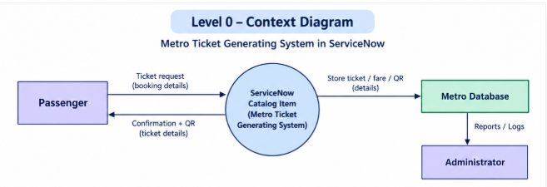
- Level‑1 (Detailed):Passenger → Booking Form → Client Script Validation → Business Rule (Fare Calculation) → QR Code Generation → Metro Database → QR Confirmation to Passenger → Administrator Dashboard
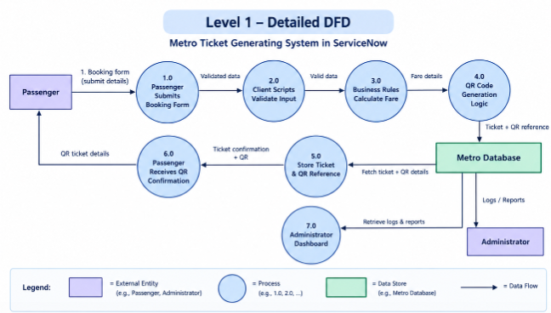

2. User Stories
User stories define functional requirements from different perspectives.
User Type | Functional Requirement (Epic) | User Story No. | User Story / Task | Acceptance Criteria | Priority | Release
Passenger | Ticket Booking | USN‑1 | As a passenger, I can book a metro ticket by selecting source, destination, and passenger type. | Ticket is generated with the correct fare based on source, destination, and passenger type. | High | Sprint‑1
Passenger | QR Code Confirmation | USN‑2 | As a passenger, I receive a QR code after booking. | QR displayed in portal and scannable. | High | Sprint‑1
Passenger | Payment Mode Selection | USN‑3 | As a passenger, I can select UPI, Card, or Other as payment mode. | Payment mode stored in ticket record. | Medium | Sprint‑2
Administrator | Transaction Monitoring | USN‑4 | As an admin, I can view ticket logs in dashboard. | Logs visible with filters. | Medium | Sprint‑2
Administrator | Error Handling | USN‑5 | As an admin, I can detect failed or duplicate transactions. | Errors flagged in dashboard. | Medium | Sprint‑3

